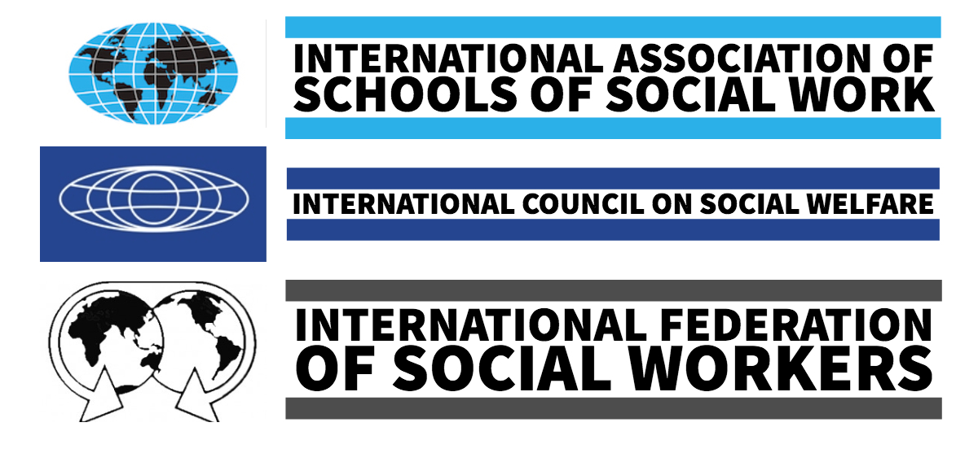
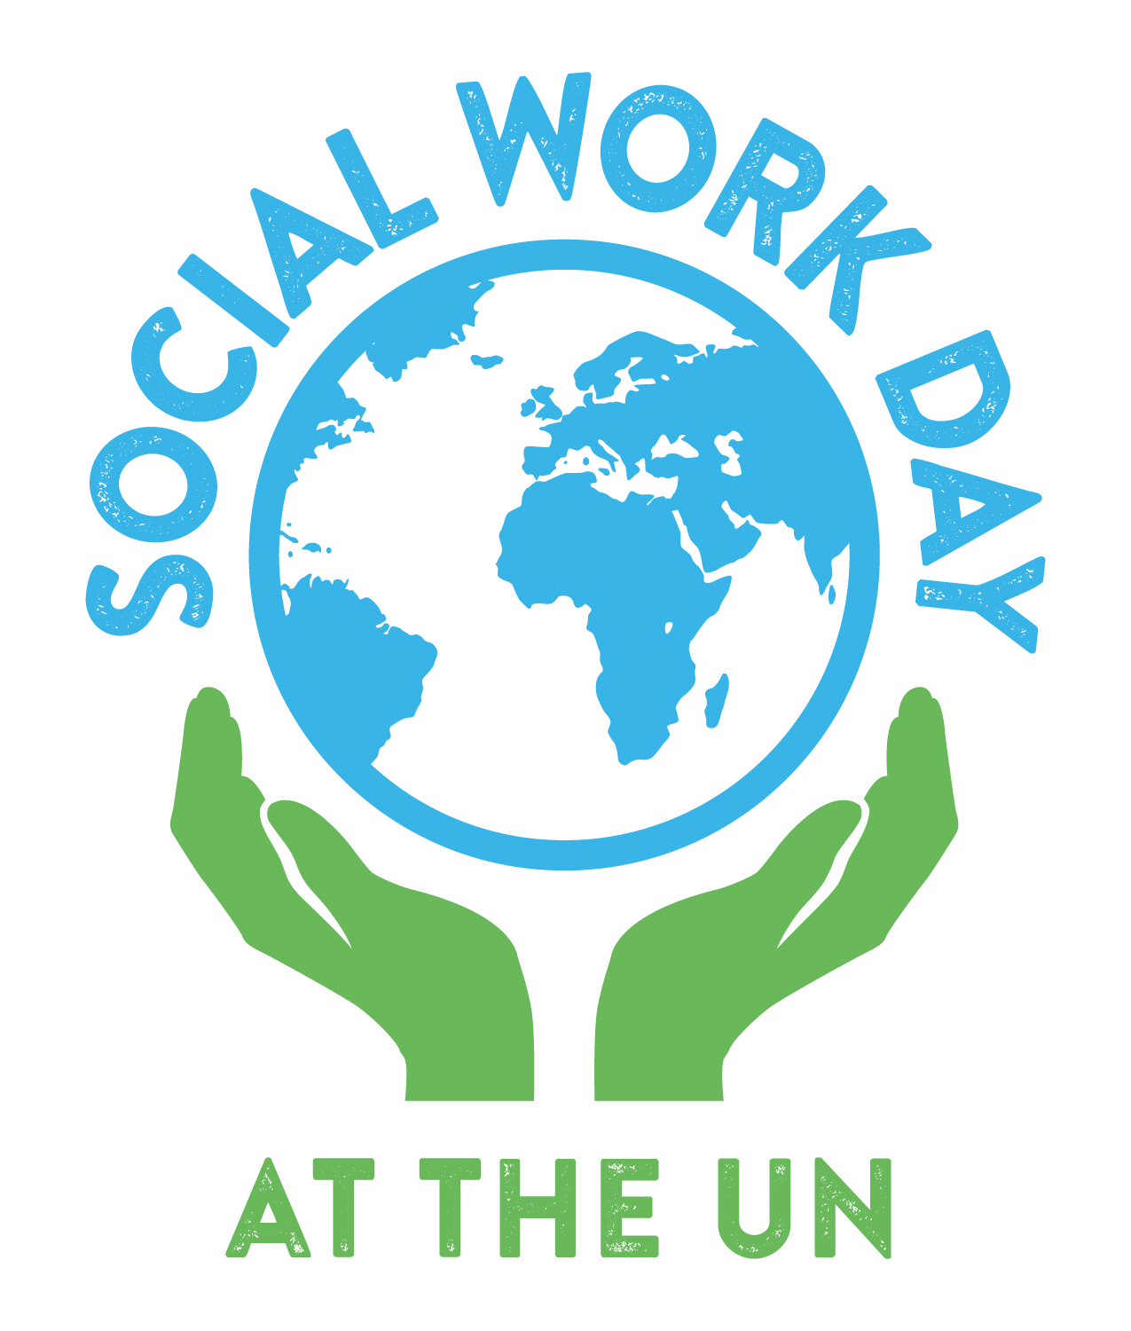
ORGANIZATIONS and PEOPLE
that planned Social Work Day
CO-CHAIRS
Shirley Gatenio Gabel, IASSW Representative
Robin Mama, IFSW Representative

PLANNING COMMITTEE MEMBERS
Abigail Asper, IFSW Student Representative
Elaine Congress, IFSW Representative
Michael Cronin, IFSW Main Representative
Rebecca Davis, IASSW Representative
Alessandro Guimaraes, IFSW Student Representative
Kristen Kimmel, IASSW Student Representative
Sergei Zelenev, ICSW Representative
@SWDayUN #SWD2019 #ProtectKids

  - Strengthening Human Relationships:
  - Policies & Programs to Protect Children
  - WELCOME to the 36th

1 April 2019, 9:30 AM – 12:00 PM

United Nations HQ, ECOSOC Chamber
SCHOOLS
Fordham University Graduate School of Social Service
Marist College Bachelor of Social Work Program
Monmouth University School of Social Work
Silberman School of Social Work at Hunter College
Saint Olaf College
University of Alabama School of Social Work
University of Georgia School of Social Work
University of Houston Graduate College of Social Work

ORGANIZATIONS
Association for Community Organization & Social Administration
Council on Social Work Education
CSWE-Katherine A. Kendall Institute
International Council on Social Welfare
International Association for Social Work with Groups
National Association of Social Workers
NASW-New Jersey
NASW-New York City
Network for Social Work Managers
9:45 OPENING REMARKS
Robin Mama Co-Chair, Social Work Day, IFSW
Shirley G. Gabel Co-Chair, Social Work Day, IASSW
9:55 WELCOME
Annamaria Campanini President, IASSW
Silvana Martinez President, IFSW
PANELISTS
10:00 H.E. GEORGI PANAYOTOV Ambassador, Permanent Mission of Bulgaria to the UN
10:20 GRIET CATTAERT Policy Officer, UN Office of the Special Rep of the Secretary-General for International Migration
10:40 WENYAN YANG Chief, Global Dialogue for Social Development Branch, UN DESA
10:55 MARIAMA DIALLO Project Director of African Initiatives, Sanctuary for Families
11:05 BUSHRA HUSAIN Forced Marriages Project, Sanctuary for Families
11:15 ANIRUDDHA KULKARNI Child Protection Specialist, UNICEF New York
11:30 CLOSING REMARKS
Sergei Zelenev Executive Director, ICSW
11:40 Q & A

THANK YOU

TO OUR

GENEROUS SPONSORS
PROGRAM
Learn more about today’s panelists online at monmouth.edu/swday

